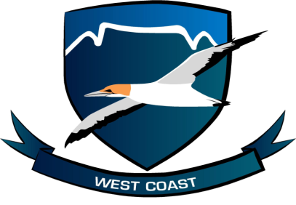 **WEST COAST CROSS COUNTRY**

**A.F SWARTS C.H.RODGERS**

**CELL: 060 963 6000 0732320046**

**Email:** [**swartsaf@gmail.com**](mailto:swartsaf@gmail.com) **Email :** [**chrodgers1@gmail.com**](mailto:chrodgers1@gmail.com)

**Saldanhabay Primary Schools Boland XC Representative**

**XC Chairman**

**WEST COAST & BOLAND CROSS COUNTRY CHAMPS EVENTS TIME TABLE : 2022**

|  |  |  |  |  |  |
| --- | --- | --- | --- | --- | --- |
| **TIME** | **CATEGORY** | **DIST.** | **RECORD** | **DATE SET** | **ROUTE** |
| 10:00 | Senior Men,Women, | 10km |  |  | New Certified Route |
| 10:05 | Girls 9 (Born **2013**) | 2 km |  |  | New Certified Route |
| Boys 9 (Born **2013**) | 2km |  |  | New Certified Route |
| 10:20 | Girls 10 (Born**2012**) | 2 km |  |  | New Certified Route |
| Boys 10 (Born **2012**) | 2km |  |  | New Certified Route |
| 10:35 | Girls 11 (Born **2011**) | 3km |  |  | New Certified Route |
| Boys 11 (Born **2011**) | 3km |  |  | New Certified Route |
| 10:50 | Girls 12 (Born **2010**) | 3km |  |  | New Certified Route |
| Boys 12 (Born **2010**) | 3km |  |  | New Certified Route |
| Girls 13 (Born **2009**) | 3km |  |  | New Certified Route |
| 11:10 | Boys 13 (Born **2009**) | 4km |  |  | New Certified Route |
| 11:35 | Junior Men 19, Master Men | 8km |  |  | New Certified Route |
| 12:55 | Boys 14 (Born **2008**) | 4km |  |  | New Certified Route |
| Girls 14 (Born **2008**) | 4km |  |  | New Certified Route |
| 12:15 | Girls 15 (Born **2007**) | 4km |  |  | New Certified Route |
| Boys 15 (Born **2007**) | 4km |  |  | New Certified Route |
| 12:35 | Girls 16 (Born **2006**) | 4km |  |  | New Certified Route |
| Girls 17 (Born **2005**) | 4km |  |  | New Certified Route |
| 12:55 | Senior Women & Men, Master Women | 4km |  |  | New Certified Route |
| 13:15 | Boys 16 (Born **2006**) | 6km |  |  | New Certified Route |
| Boys 17 (Born **2005**) | 6km |  |  | New Certified Route |
| 13:35 | Junior Women 19 , Grand Master Men | 6km |  |  | New Certified Route |